Steps to start the execution:

1. Start hub by running ‘hubStart’ from D:\Selenium ServerRun ‘’ location.
2. Register nodes by running ‘nodeRegister1’ from D:\Selenium ServerRun ‘’ location.
3. Open Command prompt and navigate to project home directory and Start Jenkins server as below

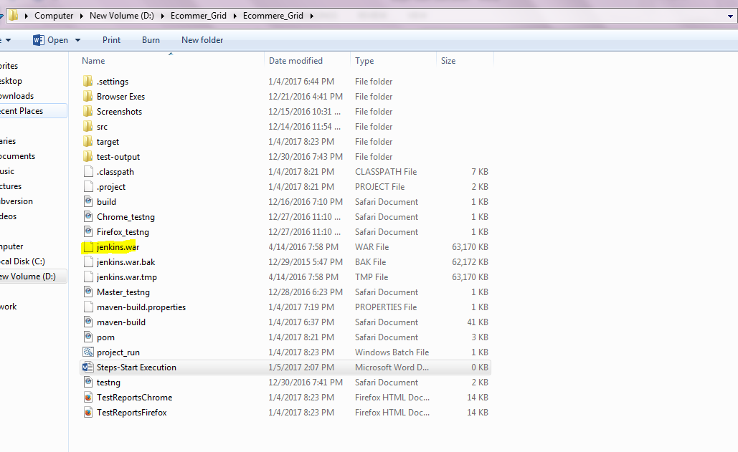

And run the command: java –jar Jenkins.war

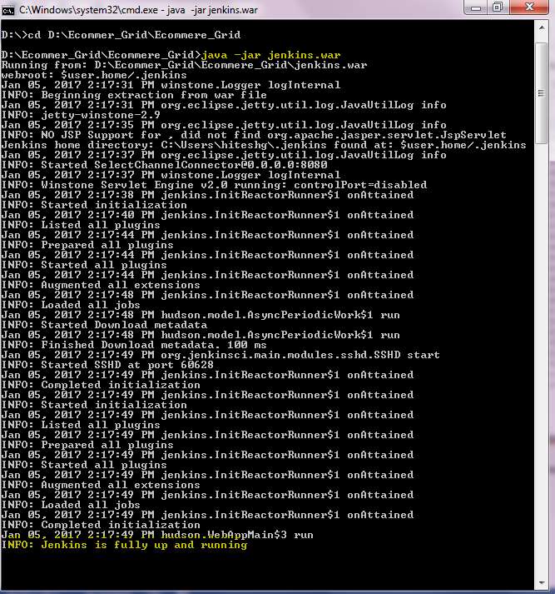

1. Open browser and access <http://localhost:8080/> to run the Jenkins.

And click on ‘build now’ link

